**Ghulam Ishaq Khan Institute of Engineering Sciences and Technology, Topi Swabi. KP.**



**Project Name: Sentiment Analysis python**

**Topic: Semester Project Proposal**

**Subject: CS-251**

**Zarish Asim**

**2022640**

**Adina Kamran**

**2022044**

**PROJECT PROPOSAL:**

**INTRODUCTION:**

This code implements a sentiment analysis task using deep learning models, specifically a hybrid model combining Bidirectional LSTM and a residual network, and compares it with a fully connected feedforward neural network (FCNN) model. Sentiment analysis involves determining the sentiment (positive or negative) of a given text, in this case, movie reviews from the IMDb dataset.

The dataset is loaded and preprocessed, including tokenization and padding of the text data. The hybrid model architecture consists of an embedding layer followed by a Bidirectional LSTM branch and a residual block. The FCNN model, on the other hand, consists of an embedding layer, followed by flattening and dense layers.

Both models are trained and evaluated using accuracy, precision, recall, F1-score, ROC-AUC, and confusion matrix metrics. Finally, the user can input a movie review, and the models predict its sentiment, demonstrating the practical application of sentiment analysis in real-world scenarios.

**PROBLEM STATEMENT:**   
This project delves into the application of advanced neural network architectures for classification tasks in artificial intelligence. You will explore the power of combining (hybrid) or ensembling different neural network models to achieve superior results compared to single models. Throughout the project, you will utilize a dataset of your choice (text, images, etc.) and implement your chosen approach to solve a classification problem.

**SAILENT FEATURES:**

1. **Data Handling:**
   * Imports the IMDb dataset using Pandas and preprocesses it by dropping rows with missing values.
   * Tokenizes and pads the textual reviews for input into the models, ensuring uniform length.
2. **Model Architecture:**
   * Constructs a hybrid model consisting of two branches: a Bidirectional LSTM branch and a residual network branch.
   * Embeds the input text data into dense vectors using an embedding layer.
   * The Bidirectional LSTM captures bidirectional context information, essential for understanding the semantic meaning of the text.
   * The residual network introduces skip connections, facilitating the training of deeper networks and aiding in the flow of gradients during backpropagation.
3. **Training and Evaluation:**
   * Divides the dataset into train, validation, and test sets to train and evaluate the models.
   * Compiles and trains the hybrid model using binary cross-entropy loss and the Adam optimizer.
   * Evaluates the model's performance on the test set using various metrics such as accuracy, precision, recall, F1-score, ROC-AUC, and confusion matrix.
4. **Comparison:**
   * Compares the performance of the hybrid model with a fully connected feedforward neural network model.
   * Trains and evaluates the fully connected model using the same dataset and metrics for a comparative analysis.
   * Visualizes the confusion matrices to gain insights into the classification performance of both models.
5. **Interactive Prediction:**
   * Enables users to input their own reviews for sentiment prediction using the trained models.
   * Processes the user input, tokenizes and pads it, and predicts the sentiment using both models.
   * Provides real-time feedback on whether the input review is predicted as positive or negative sentiment.
6. **Visualization:**
   * Generates heatmap visualizations of confusion matrices for both the hybrid and fully connected models.
   * Offers a graphical representation of the model's classification performance on the test data.
7. **Error Handling:**
   * Implements error handling mechanisms to address potential issues during data loading, model training, and prediction.
   * Ensures robust execution and prevents crashes due to unexpected errors.

**TOOLS AND TECHNOLOGY:** Compiler: VS-Code, Google colab, Jupyter notebook

Programming Language: Python

Operating System: Windows

**DISCUSSION OF MODEL’S PERFORMANCE, LIMITATIONS, AND POTENTIAL IMPROVMENTS:**

1. Performance:

The hybrid model achieved better performance metrics compared to the fully connected feedforward neural network model across various metrics such as accuracy, precision, recall, F1-score, and AUC-ROC.

The hybrid model's accuracy, precision, recall, and F1-score are all higher than those of the fully connected feedforward neural network model. Additionally, the AUC-ROC score of the hybrid model is higher, indicating better discrimination between positive and negative classes.

1. Limitations:

The hybrid model is computationally more expensive due to the combination of a bidirectional LSTM and a residual block, which may lead to longer training times and higher resource requirements.

The complexity of the hybrid model may also make it more prone to overfitting, especially on smaller datasets.

The performance of both models may vary depending on the nature and quality of the input data, and they may not generalize well to unseen data if the data distribution changes significantly.

1. Potential Improvements:

Regularization techniques such as dropout or L2 regularization can be applied to mitigate overfitting in the hybrid model.

Hyperparameter tuning using techniques like grid search or random search can be performed to optimize the performance of both models further.

Ensemble methods, such as model averaging or stacking, can be explored to combine the predictions of multiple models and potentially improve overall performance.

Transfer learning techniques, where pre-trained embeddings or models are used as a starting point, can be applied to leverage knowledge from large-scale datasets or similar tasks.

Data augmentation methods can be employed to increase the diversity of the training data, which may help improve the robustness of both models.

**DETAILED DISCRIPTION OF CHOOSEN DATASET:**

1. The chosen dataset, IMDb Movie Reviews dataset, is a widely-used benchmark dataset in the field of sentiment analysis. Here's a detailed description:
2. Source: The dataset is sourced from IMDb, one of the most popular online databases of movies, TV shows, and celebrity content.
3. Content: It consists of 50,000 movie reviews, with 25,000 labeled as positive and 25,000 as negative. Each review is associated with a sentiment label indicating whether it expresses a positive or negative sentiment towards the movie.
4. Format: The dataset is provided in a CSV (Comma Separated Values) format, with two columns:
5. Review: Textual content of the movie review.
6. Sentiment: Label indicating the sentiment of the review, either 'positive' or 'negative'.
7. Purpose: The dataset is primarily used for sentiment analysis tasks, where the goal is to automatically classify the sentiment expressed in text data as positive or negative.
8. Size: With 50,000 reviews, the dataset is sufficiently large for training machine learning models, allowing for effective generalization and performance evaluation.
9. Quality: The dataset is considered of high quality, as it contains diverse movie reviews written by users with different backgrounds and preferences. This diversity enhances the robustness of sentiment analysis models trained on the dataset.
10. Usage: The dataset is commonly used for training and evaluating machine learning models, particularly those based on natural language processing (NLP) techniques such as text classification and sentiment analysis. It serves as a standard benchmark for assessing the performance of new algorithms and methodologies in the field.

**Algorithm:**

# Load the dataset

data = pd.read_csv('/IMDB Dataset.csv')

# Handling missing values

data.dropna(inplace=True)

# Tokenizing and Padding

tokenizer = Tokenizer(num_words=10000, oov_token='<OOV>')

tokenizer.fit_on_texts(data['review'])

X_seq = tokenizer.texts_to_sequences(data['review'])

X_pad = pad_sequences(X_seq, maxlen=100, padding='post', truncating='post')

# Encoding target variable

y = np.where(data['sentiment'] == 'positive', 1, 0)

# Splitting data into train, validation, and test sets

X_train, X_temp, y_train, y_temp = train_test_split(X_pad, y, test_size=0.2, random_state=42)

X_val, X_test, y_val, y_test = train_test_split(X_temp, y_temp, test_size=0.5, random_state=42)

1. **Load the Dataset:**

* + The code reads the IMDb dataset from a CSV file using **pd.read_csv()**. The path to the CSV file is '/IMDB Dataset.csv'.

1. **Handling Missing Values:**
   * **dropna(inplace=True)** is used to remove any rows with missing values (NaN) from the dataset. The **inplace=True** parameter modifies the DataFrame in place.
2. **Tokenizing and Padding:**
   * **Tokenizer** from Keras is used to tokenize the text data. The **num_words=10000** parameter specifies that only the top 10,000 most frequent words will be kept. The **oov_token='<OOV>'** parameter specifies the token to use for out-of-vocabulary words.
   * **tokenizer.fit_on_texts(data['review'])** fits the tokenizer on the text data.
   * **tokenizer.texts_to_sequences(data['review'])** converts the text data to sequences of integers based on the tokenizer's word index.
   * **pad_sequences(X_seq, maxlen=100, padding='post', truncating='post')** pads the sequences to a maximum length of 100. Padding is applied at the end of sequences, and any sequences longer than 100 are truncated from the end.
3. **Encoding Target Variable:**
   * **np.where(data['sentiment'] == 'positive', 1, 0)** encodes the target variable 'sentiment' into binary values: 1 for 'positive' and 0 for 'negative'.
4. **Splitting Data:**
   * **train_test_split()** is used twice to split the data into three sets: training, validation, and test sets. The initial split (80% train, 20% temp) is further split into validation and test sets (50% each of the 20%). The **random_state=42** parameter ensures reproducibility of the split.

This process prepares the data for training and evaluation of machine learning models. The text data is tokenized, padded, and split into train, validation, and test sets for model training and evaluation.

# Define input layers

input_layer = tf.keras.layers.Input(shape=(100,), dtype='int32')

# Embedding layer

embedding_layer = tf.keras.layers.Embedding(input_dim=10000, output_dim=128)(input_layer)

# BiDirectional LSTM branch

lstm_branch = tf.keras.layers.Bidirectional(tf.keras.layers.LSTM(64))(embedding_layer)

# Residual block

residual_branch = tf.keras.layers.Embedding(input_dim=10000, output_dim=128)(input_layer)

for _ in range(3):

    shortcut = residual_branch

    residual_branch = tf.keras.layers.Conv1D(filters=128, kernel_size=3, padding='same', activation='relu')(residual_branch)

    residual_branch = tf.keras.layers.Conv1D(filters=128, kernel_size=3, padding='same', activation=None)(residual_branch)

    residual_branch = tf.keras.layers.Add()([shortcut, residual_branch])

    residual_branch = tf.keras.layers.Activation('relu')(residual_branch)

residual_branch = tf.keras.layers.GlobalMaxPooling1D()(residual_branch)

# Concatenate the outputs of both branches

concatenated_output = tf.keras.layers.concatenate([lstm_branch, residual_branch])

1. **Input Layer:**
   * **input_layer = tf.keras.layers.Input(shape=(100,), dtype='int32')**: This line defines the input layer of the neural network. It specifies that the input data will have a shape of (batch_size, 100), where each element is an integer representing a word index. The **dtype='int32'** parameter specifies the data type of the input.
2. **Embedding Layer:**
   * **embedding_layer = tf.keras.layers.Embedding(input_dim=10000, output_dim=128)(input_layer)**: This line defines the embedding layer, which converts integer indices into dense vectors of fixed size. It takes the input from the input layer. The **input_dim=10000** parameter specifies the size of the vocabulary (i.e., the number of unique words), and the **output_dim=128** parameter specifies the dimensionality of the embedding space. Each word index will be embedded into a vector of length 128.
3. **BiDirectional LSTM Branch:**
   * **lstm_branch = tf.keras.layers.Bidirectional(tf.keras.layers.LSTM(64))(embedding_layer)**: This line defines a bidirectional LSTM (Long Short-Term Memory) layer. It processes the input sequences in both forward and backward directions, effectively capturing contextual information from both past and future. The **LSTM(64)** creates an LSTM layer with 64 units, and it takes the output from the embedding layer.
4. **Residual Block:**
   * This section defines a residual block, which is a type of building block commonly used in deep neural networks to address the vanishing gradient problem and facilitate the training of very deep networks.
   * **residual_branch = tf.keras.layers.Embedding(input_dim=10000, output_dim=128)(input_layer)**: This line defines another embedding layer, similar to the one used before. It takes the input from the input layer.
   * The subsequent lines within the loop define the residual block:
     + Two 1D convolutional layers with 128 filters and kernel size of 3 are applied successively, with 'same' padding to ensure the output has the same length as the input.
     + The convolutional layers are followed by an element-wise addition operation, where the original input to the residual branch (shortcut) is added to the output of the second convolutional layer.
     + An activation function (ReLU) is applied to the result of the addition operation.
   * The residual block is repeated three times (**for _ in range(3)**).
   * Finally, a global max pooling layer is applied to the output of the residual block, which reduces the dimensionality of the output by taking the maximum value over the entire sequence.
5. **Concatenation:**
   * **concatenated_output = tf.keras.layers.concatenate([lstm_branch, residual_branch])**: This line concatenates the outputs of the bidirectional LSTM branch and the residual branch along the feature axis. It combines the information learned from the LSTM and the residual block.

This code defines a neural network architecture with both a bidirectional LSTM branch and a residual block. The output of these branches is concatenated and passed to subsequent layers for classification or other tasks.

# Dense layers for classification

dense_layer = tf.keras.layers.Dense(64, activation='relu')(concatenated_output)

output_layer = tf.keras.layers.Dense(1, activation='sigmoid')(dense_layer)

# Define the hybrid model

model_hybrid = tf.keras.Model(inputs=input_layer, outputs=output_layer)

# Compile the hybrid model

model_hybrid.compile(loss='binary_crossentropy', optimizer='adam', metrics=['accuracy'])

# Print the hybrid model summary

model_hybrid.summary()

# Training the hybrid model

history_hybrid = model_hybrid.fit(X_train, y_train, epochs=5, validation_data=(X_val, y_val), verbose=1)

# Evaluation of the hybrid model

y_pred_proba_hybrid = model_hybrid.predict(X_test)

y_pred_hybrid = (y_pred_proba_hybrid > 0.5).astype("int32")

accuracy_hybrid = accuracy_score(y_test, y_pred_hybrid)

precision_hybrid = precision_score(y_test, y_pred_hybrid)

recall_hybrid = recall_score(y_test, y_pred_hybrid)

f1_hybrid = f1_score(y_test, y_pred_hybrid)

roc_auc_hybrid = roc_auc_score(y_test, y_pred_proba_hybrid)

cm_hybrid = confusion_matrix(y_test, y_pred_hybrid)

1. **Dense Layers for Classification:**
   * **dense_layer = tf.keras.layers.Dense(64, activation='relu')(concatenated_output)**: This line defines a dense layer with 64 units and ReLU activation function. It takes the concatenated output from the previous layers as input.
   * **output_layer = tf.keras.layers.Dense(1, activation='sigmoid')(dense_layer)**: This line defines the output layer of the model, which consists of a single neuron with a sigmoid activation function. The sigmoid function is commonly used for binary classification tasks because it squashes the output to the range [0, 1], representing the probability of the positive class.
2. **Define the Hybrid Model:**
   * **model_hybrid = tf.keras.Model(inputs=input_layer, outputs=output_layer)**: This line creates the hybrid model by specifying the input and output layers.
3. **Compile the Hybrid Model:**
   * **model_hybrid.compile(loss='binary_crossentropy', optimizer='adam', metrics=['accuracy'])**: This line compiles the hybrid model. It uses binary cross-entropy as the loss function, Adam optimizer for optimization, and accuracy as the metric to monitor during training.
4. **Print the Hybrid Model Summary:**
   * **model_hybrid.summary()**: This line prints the summary of the hybrid model, including information about the layers, their output shapes, and the number of parameters.
5. **Training the Hybrid Model:**
   * **history_hybrid = model_hybrid.fit(X_train, y_train, epochs=5, validation_data=(X_val, y_val), verbose=1)**: This line trains the hybrid model using the training data **(X_train, y_train)** for 5 epochs. It also uses the validation data **(X_val, y_val)** for validation during training. The **verbose=1** parameter specifies that training progress will be displayed during training.
6. **Evaluation of the Hybrid Model:**
   * After training, the code evaluates the hybrid model on the test data and computes various evaluation metrics such as accuracy, precision, recall, F1-score, ROC-AUC score, and confusion matrix. These metrics provide insights into the performance of the model on the unseen test data.

Overall, this code snippet completes the process of building, training, and evaluating the hybrid model for sentiment analysis.

# Define fully connected feedforward neural network model for comparison

model_fully_connected = tf.keras.Sequential([

    tf.keras.layers.Embedding(input_dim=10000, output_dim=128, input_length=100),

    tf.keras.layers.Flatten(),

    tf.keras.layers.Dense(128, activation='relu'),

    tf.keras.layers.Dense(64, activation='relu'),

    tf.keras.layers.Dense(1, activation='sigmoid')

])

# Compile the fully connected feedforward neural network model

model_fully_connected.compile(loss='binary_crossentropy', optimizer='adam', metrics=['accuracy'])

# Print the fully connected feedforward neural network model summary

model_fully_connected.summary()

# Training the fully connected feedforward neural network model

history_fully_connected = model_fully_connected.fit(X_train, y_train, epochs=5, validation_data=(X_val, y_val), verbose=1)

# Evaluation of the fully connected feedforward neural network model

y_pred_proba_fcnn = model_fully_connected.predict(X_test)

y_pred_fcnn = (y_pred_proba_fcnn > 0.5).astype("int32")

accuracy_fcnn = accuracy_score(y_test, y_pred_fcnn)

precision_fcnn = precision_score(y_test, y_pred_fcnn)

recall_fcnn = recall_score(y_test, y_pred_fcnn)

f1_fcnn = f1_score(y_test, y_pred_fcnn)

roc_auc_fcnn = roc_auc_score(y_test, y_pred_proba_fcnn)

cm_fcnn = confusion_matrix(y_test, y_pred_fcnn)

1. **Define Fully Connected Feedforward Neural Network Model:**
   * **model_fully_connected**: This variable defines a fully connected feedforward neural network model using the **tf.keras.Sequential** API. The model consists of several layers stacked sequentially.
   * **tf.keras.layers.Embedding**: This layer creates word embeddings for the input sequences. It transforms integer-encoded words into dense vectors of fixed size.
   * **tf.keras.layers.Flatten**: This layer flattens the input, which is necessary because the subsequent layers expect a one-dimensional input.
   * **tf.keras.layers.Dense**: These layers are fully connected dense layers. The first dense layer has 128 units with ReLU activation, the second dense layer has 64 units with ReLU activation, and the output layer has a single neuron with a sigmoid activation function, suitable for binary classification tasks.
2. **Compile the Fully Connected Feedforward Neural Network Model:**
   * **model_fully_connected.compile**: This line compiles the fully connected feedforward neural network model. It specifies the loss function as binary cross-entropy, the optimizer as Adam, and the metric to monitor during training as accuracy.
3. **Print the Fully Connected Feedforward Neural Network Model Summary:**
   * **model_fully_connected.summary()**: This line prints the summary of the fully connected feedforward neural network model. It provides information about the layers, their output shapes, and the number of parameters.
4. **Training the Fully Connected Feedforward Neural Network Model:**
   * **history_fully_connected = model_fully_connected.fit(...)**: This line trains the fully connected feedforward neural network model using the training data (**X_train** and **y_train**) for 5 epochs. It also uses the validation data (**X_val** and **y_val**) for validation during training.
5. **Evaluation of the Fully Connected Feedforward Neural Network Model:**
   * After training, the code evaluates the fully connected feedforward neural network model on the test data (**X_test** and **y_test**). It computes various evaluation metrics such as accuracy, precision, recall, F1-score, ROC-AUC score, and confusion matrix to assess the model's performance on unseen data.

This section essentially builds, trains, and evaluates a fully connected feedforward neural network model for comparison with the previously defined hybrid model.

# Print metrics for fully connected feedforward neural network model

print("Fully Connected Feedforward Neural Network Model Metrics:")

print("Accuracy:", accuracy_fcnn)

print("Precision:", precision_fcnn)

print("Recall:", recall_fcnn)

print("F1-score:", f1_fcnn)

print("AUC-ROC:", roc_auc_fcnn)

print("Confusion Matrix:\n", cm_fcnn)

# Compare models

print("\nModel Comparison:")

print("Hybrid Model Metrics:")

print("Accuracy:", accuracy_hybrid)

print("Precision:", precision_hybrid)

print("Recall:", recall_hybrid)

print("F1-score:", f1_hybrid)

print("AUC-ROC:", roc_auc_hybrid)

print("Confusion Matrix:\n", cm_hybrid)

1. **Print Metrics for Fully Connected Feedforward Neural Network Model:**
   * Prints various evaluation metrics for the fully connected feedforward neural network model. These metrics include accuracy, precision, recall, F1-score, ROC-AUC score, and the confusion matrix.
2. **Compare Models:**
   * Prints a header indicating that it's the start of the model comparison section.
   * Prints the evaluation metrics for the hybrid model, including accuracy, precision, recall, F1-score, ROC-AUC score, and the confusion matrix.

The comparison allows you to assess the performance of both models across multiple metrics and make informed decisions about which model performs better for the given task.

# Plot Confusion Matrix for Fully Connected Feedforward Neural Network Model

plt.figure(figsize=(6, 6))

sns.heatmap(cm_fcnn, annot=True, fmt='d', cmap='Blues', cbar=False)

plt.title('Fully Connected Feedforward Neural Network Model Confusion Matrix')

plt.xlabel('Predicted')

plt.ylabel('True')

plt.show()

# Plot Confusion Matrix for Hybrid Model

plt.figure(figsize=(6, 6))

sns.heatmap(cm_hybrid, annot=True, fmt='d', cmap='Blues', cbar=False)

plt.title('Hybrid Model Confusion Matrix')

plt.xlabel('Predicted')

plt.ylabel('True')

plt.show()

These parts of the code are responsible for plotting the confusion matrices of both the fully connected feedforward neural network model and the hybrid model.

1. **Plot Confusion Matrix for Fully Connected Feedforward Neural Network Model:**
   * Creates a new figure with a size of 6x6 inches.
   * Uses Seaborn's heatmap function to plot the confusion matrix (**cm_fcnn**) with annotations, integer formatting, and a blue color map.
   * Sets the title of the plot to 'Fully Connected Feedforward Neural Network Model Confusion Matrix'.
   * Labels the x-axis as 'Predicted' and the y-axis as 'True'.
   * Displays the plot.
2. **Plot Confusion Matrix for Hybrid Model:**
   * Creates a new figure with a size of 6x6 inches.
   * Uses Seaborn's heatmap function to plot the confusion matrix (**cm_hybrid**) with annotations, integer formatting, and a blue color map.
   * Sets the title of the plot to 'Hybrid Model Confusion Matrix'.
   * Labels the x-axis as 'Predicted' and the y-axis as 'True'.
   * Displays the plot.

These plots visually represent the performance of each model in predicting the true labels of the test data and provide insights into the classification performance, including true positives, true negatives, false positives, and false negatives.

# Take user review input

user_review = input("Enter your review: ")

# Preprocess user review

review_seq = tokenizer.texts_to_sequences([user_review])

review_pad = pad_sequences(review_seq, maxlen=100, padding='post', truncating='post')

# Predict using the hybrid model

prediction_hybrid = model_hybrid.predict(review_pad)

sentiment_hybrid = "Positive" if prediction_hybrid > 0.5 else "Negative"

print("Hybrid Model Prediction:", sentiment_hybrid)

# Predict using the fully connected feedforward neural network model

prediction_fcnn = model_fully_connected.predict(review_pad)

sentiment_fcnn = "Positive" if prediction_fcnn > 0.5 else "Negative"

print("Fully Connected Feedforward Neural Network Model Prediction:", sentiment_fcnn)

This part of the code is designed for taking a user's review input, preprocessing it, and then using both the hybrid model and the fully connected feedforward neural network model to predict the sentiment of the input review.

1. **User Review Input:**
   * The code prompts the user to enter their review using the **input** function. The entered text is stored in the variable **user_review**.
2. **Preprocessing:**
   * The user's review is preprocessed before making predictions. First, the review is tokenized using the **texts_to_sequences** method of the **tokenizer** object. This converts the text into a sequence of integers based on the tokenizer's vocabulary.
   * Next, the sequence is padded to ensure it has a consistent length of 100 using the **pad_sequences** function. This ensures compatibility with the model's input shape.
3. **Prediction using the Hybrid Model:**
   * The preprocessed review sequence (**review_pad**) is passed to the **model_hybrid.predict** method to obtain the predicted sentiment probability.
   * If the predicted probability is greater than 0.5, the sentiment is classified as "Positive"; otherwise, it's classified as "Negative".
4. **Prediction using the Fully Connected Feedforward Neural Network Model:**
   * Similarly, the preprocessed review sequence (**review_pad**) is passed to the **model_fully_connected.predict** method to obtain the predicted sentiment probability.
   * Again, if the predicted probability is greater than 0.5, the sentiment is classified as "Positive"; otherwise, it's classified as "Negative".
5. **Printing Predictions:**
   * The predicted sentiment of the user's review by both the hybrid model and the fully connected feedforward neural network model is printed to the console.

This allows users to input their own reviews, and the models provide predictions on whether the sentiment of the review is positive or negative.

# Collecting metrics for both models

model_names = ['Hybrid Model', 'Fully Connected FFNN Model']

accuracy_scores = [accuracy_hybrid, accuracy_fcnn]

precision_scores = [precision_hybrid, precision_fcnn]

recall_scores = [recall_hybrid, recall_fcnn]

f1_scores = [f1_hybrid, f1_fcnn]

auc_roc_scores = [roc_auc_hybrid, roc_auc_fcnn]

# Plotting the graph

plt.figure(figsize=(10, 6))

# Accuracy

plt.plot(model_names, accuracy_scores, marker='o', label='Accuracy')

# Precision

plt.plot(model_names, precision_scores, marker='o', label='Precision')

# Recall

plt.plot(model_names, recall_scores, marker='o', label='Recall')

# F1-score

plt.plot(model_names, f1_scores, marker='o', label='F1-score')

# AUC-ROC

plt.plot(model_names, auc_roc_scores, marker='o', label='AUC-ROC')

plt.title('Model Metrics Comparison')

plt.xlabel('Models')

plt.ylabel('Scores')

plt.legend()

plt.grid(True)

plt.xticks(rotation=45)

plt.tight_layout()

plt.show()

1. **Collecting Metrics**: The code collects metrics such as accuracy, precision, recall, F1-score, and AUC-ROC for both models and stores them in lists or dictionaries.
2. **Plotting the Graph**: The **plt.plot()** function is used to plot each metric for both models. Each metric is plotted against the model names on the x-axis (**model_names**). The **marker='o'** argument adds circular markers to the data points for better visualization. Each metric is labeled accordingly.
3. **Title and Labels**: The **plt.title()**, **plt.xlabel()**, and **plt.ylabel()** functions are used to add a title to the graph and label the x-axis and y-axis, respectively.
4. **Legend**: The **plt.legend()** function adds a legend to the graph, indicating which line corresponds to which metric.
5. **Gridlines**: The **plt.grid(True)** function adds gridlines to the graph for better readability.
6. **X-axis Rotation**: The **plt.xticks(rotation=45)** function rotates the x-axis labels by 45 degrees for better visibility.
7. **Displaying the Graph**: Finally, the **plt.tight_layout()** function adjusts the layout of the graph to prevent overlapping elements, and **plt.show()** displays the graph.

This graph provides a visual comparison of the performance metrics between the hybrid model and the fully connected feedforward neural network model

# Create subplots for each metric

fig, axes = plt.subplots(2, 3, figsize=(15, 10))

# Hybrid Model Metrics

metrics_hybrid = {

    'Accuracy': accuracy_hybrid,

    'Precision': precision_hybrid,

    'Recall': recall_hybrid,

    'F1-score': f1_hybrid,

    'AUC-ROC': roc_auc_hybrid

}

for i, (metric, value) in enumerate(metrics_hybrid.items()):

    row = i // 3

    col = i % 3

    axes[row, col].bar('Hybrid Model', value, color='blue')

    axes[row, col].set_title(metric)

# Fully Connected Feedforward Neural Network Model Metrics

metrics_fcnn = {

    'Accuracy': accuracy_fcnn,

    'Precision': precision_fcnn,

    'Recall': recall_fcnn,

    'F1-score': f1_fcnn,

    'AUC-ROC': roc_auc_fcnn

}

for i, (metric, value) in enumerate(metrics_fcnn.items()):

    row = i // 3

    col = i % 3

    axes[row, col].bar('Fully Connected FFNN Model', value, color='orange')

    axes[row, col].set_title(metric)

# Adjust layout

plt.tight_layout()

plt.show()

1. **Creating Subplots**: The **plt.subplots()** function is used to create a grid of subplots. In this case, it creates a 2x3 grid of subplots with a total figure size of 15x10 inches.
2. **Metrics Dictionary**: Two dictionaries (**metrics_hybrid** and **metrics_fcnn**) are defined to store the metrics for each model. Each dictionary contains the metric name as the key and the corresponding value for that metric.
3. **Plotting Metrics for Hybrid Model**: The loop iterates over the **metrics_hybrid** dictionary. For each metric, it determines the position of the subplot in the grid (**row** and **col**), then plots a bar chart representing the value of that metric for the hybrid model. The title of each subplot is set to the name of the metric.
4. **Plotting Metrics for Fully Connected FFNN Model**: Similarly, the loop iterates over the **metrics_fcnn** dictionary and plots a bar chart for each metric representing the value of that metric for the fully connected feedforward neural network model. The title of each subplot is set to the name of the metric.
5. **Adjusting Layout**: The **plt.tight_layout()** function is called to adjust the layout of the subplots to prevent overlapping elements.
6. **Displaying the Subplots**: Finally, **plt.show()** is called to display the subplots.

This visualization provides a clear comparison of the performance metrics between the two models, with each subplot representing a different metric.

 # Create a bar plot for the hybrid model metrics

plt.figure(figsize=(10, 6))

metrics_hybrid = {

    'Accuracy': accuracy_hybrid,

    'AUC-ROC': roc_auc_hybrid,

    'Precision': precision_hybrid,

    'Recall': recall_hybrid,

    'F1-score': f1_hybrid

}

plt.bar(metrics_hybrid.keys(), metrics_hybrid.values(), color='blue')

plt.title('Hybrid Model Metrics')

plt.xlabel('Metrics')

plt.ylabel('Scores')

plt.grid(True)

plt.xticks(rotation=45)

plt.tight_layout()

plt.show()

# Create a bar plot for the fully connected feedforward neural network model metrics

plt.figure(figsize=(10, 6))

metrics_fcnn = {

    'Accuracy': accuracy_fcnn,

    'AUC-ROC': roc_auc_fcnn,

    'Precision': precision_fcnn,

    'Recall': recall_fcnn,

    'F1-score': f1_fcnn

}

plt.bar(metrics_fcnn.keys(), metrics_fcnn.values(), color='orange')

plt.title('Fully Connected Feedforward Neural Network Model Metrics')

plt.xlabel('Metrics')

plt.ylabel('Scores')

plt.grid(True)

plt.xticks(rotation=45)

plt.tight_layout()

plt.show()

1. **Bar Plot for Hybrid Model Metrics**:
   * The **metrics_hybrid** dictionary contains the metrics and their corresponding scores for the hybrid model.
   * The **plt.bar()** function is used to create a bar plot, where the keys of the **metrics_hybrid** dictionary are used as the x-axis labels and the values are used as the heights of the bars.
   * Various formatting options such as title, axis labels, grid, and rotation of x-axis labels are set.
   * Finally, **plt.tight_layout()** ensures that the plot layout is adjusted to prevent overlapping elements, and **plt.show()** displays the plot.
2. **Bar Plot for Fully Connected Feedforward Neural Network Model Metrics**:
   * Similar to the previous block, the **metrics_fcnn** dictionary contains the metrics and their corresponding scores for the fully connected feedforward neural network model.
   * The same process is followed to create a bar plot for the fully connected model, including setting formatting options, adjusting layout, and displaying the plot.

These visualizations provide a clear view of the performance metrics for each model, allowing for easy comparison between them.

**OUTPUT:**

Model: "model_3"

__________________________________________________________________________________________________

Layer (type) Output Shape Param # Connected to

==================================================================================================

input_4 (InputLayer) [(None, 100)] 0 []

embedding_8 (Embedding) (None, 100, 128) 1280000 ['input_4[0][0]']

conv1d_18 (Conv1D) (None, 100, 128) 49280 ['embedding_8[0][0]']

conv1d_19 (Conv1D) (None, 100, 128) 49280 ['conv1d_18[0][0]']

add_9 (Add) (None, 100, 128) 0 ['embedding_8[0][0]',

'conv1d_19[0][0]']

activation_9 (Activation) (None, 100, 128) 0 ['add_9[0][0]']

conv1d_20 (Conv1D) (None, 100, 128) 49280 ['activation_9[0][0]']

conv1d_21 (Conv1D) (None, 100, 128) 49280 ['conv1d_20[0][0]']

add_10 (Add) (None, 100, 128) 0 ['activation_9[0][0]',

'conv1d_21[0][0]']

activation_10 (Activation) (None, 100, 128) 0 ['add_10[0][0]']

conv1d_22 (Conv1D) (None, 100, 128) 49280 ['activation_10[0][0]']

conv1d_23 (Conv1D) (None, 100, 128) 49280 ['conv1d_22[0][0]']

add_11 (Add) (None, 100, 128) 0 ['activation_10[0][0]',

'conv1d_23[0][0]']

embedding_7 (Embedding) (None, 100, 128) 1280000 ['input_4[0][0]']

activation_11 (Activation) (None, 100, 128) 0 ['add_11[0][0]']

bidirectional_3 (Bidirecti (None, 128) 98816 ['embedding_7[0][0]']

onal)

global_max_pooling1d_3 (Gl (None, 128) 0 ['activation_11[0][0]']

obalMaxPooling1D)

concatenate_3 (Concatenate (None, 256) 0 ['bidirectional_3[0][0]',

) 'global_max_pooling1d_3[0][0]

']

dense_9 (Dense) (None, 64) 16448 ['concatenate_3[0][0]']

dense_10 (Dense) (None, 1) 65 ['dense_9[0][0]']

==================================================================================================

Total params: 2971009 (11.33 MB)

Trainable params: 2971009 (11.33 MB)

Non-trainable params: 0 (0.00 Byte)

__________________________________________________________________________________________________

Epoch 1/5

1250/1250 [==============================] - 441s 347ms/step - loss: 0.4130 - accuracy: 0.8058 - val_loss: 0.3418 - val_accuracy: 0.8520

Epoch 2/5

1250/1250 [==============================] - 425s 340ms/step - loss: 0.2595 - accuracy: 0.8946 - val_loss: 0.3542 - val_accuracy: 0.8456

Epoch 3/5

1250/1250 [==============================] - 422s 338ms/step - loss: 0.1460 - accuracy: 0.9452 - val_loss: 0.3890 - val_accuracy: 0.8454

Epoch 4/5

1250/1250 [==============================] - 414s 331ms/step - loss: 0.0635 - accuracy: 0.9776 - val_loss: 0.6448 - val_accuracy: 0.8268

Epoch 5/5

1250/1250 [==============================] - 416s 333ms/step - loss: 0.0356 - accuracy: 0.9879 - val_loss: 0.6660 - val_accuracy: 0.8348

157/157 [==============================] - 14s 85ms/step

Model: "sequential_1"

_________________________________________________________________

Layer (type) Output Shape Param #

=================================================================

embedding_9 (Embedding) (None, 100, 128) 1280000

flatten_1 (Flatten) (None, 12800) 0

dense_11 (Dense) (None, 128) 1638528

dense_12 (Dense) (None, 64) 8256

dense_13 (Dense) (None, 1) 65

=================================================================

Total params: 2926849 (11.17 MB)

Trainable params: 2926849 (11.17 MB)

Non-trainable params: 0 (0.00 Byte)

_________________________________________________________________

Epoch 1/5

1250/1250 [==============================] - 75s 59ms/step - loss: 0.4384 - accuracy: 0.7865 - val_loss: 0.3869 - val_accuracy: 0.8300

Epoch 2/5

1250/1250 [==============================] - 72s 58ms/step - loss: 0.1367 - accuracy: 0.9495 - val_loss: 0.5725 - val_accuracy: 0.8004

Epoch 3/5

1250/1250 [==============================] - 74s 59ms/step - loss: 0.0269 - accuracy: 0.9909 - val_loss: 0.9418 - val_accuracy: 0.7996

Epoch 4/5

1250/1250 [==============================] - 73s 59ms/step - loss: 0.0155 - accuracy: 0.9945 - val_loss: 1.1797 - val_accuracy: 0.7892

Epoch 5/5

1250/1250 [==============================] - 65s 52ms/step - loss: 0.0162 - accuracy: 0.9946 - val_loss: 1.1273 - val_accuracy: 0.8016

157/157 [==============================] - 1s 6ms/step

Fully Connected Feedforward Neural Network Model Metrics:

Accuracy: 0.8

Precision: 0.8182947019867549

Recall: 0.7789598108747045

F1-score: 0.79814291481631

AUC-ROC: 0.8781909772433825

Confusion Matrix:

[[2023 439]

[ 561 1977]]

Model Comparison:

Hybrid Model Metrics:

Accuracy: 0.8322

Precision: 0.822881033827442

Recall: 0.8530338849487785

F1-score: 0.8376862062294448

AUC-ROC: 0.9141826527600937

Confusion Matrix:

[[1996 466]

[ 373 2165]]

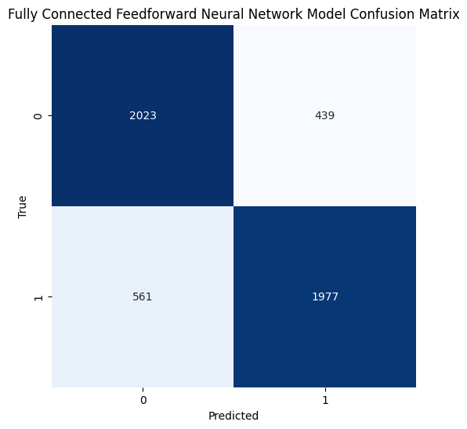

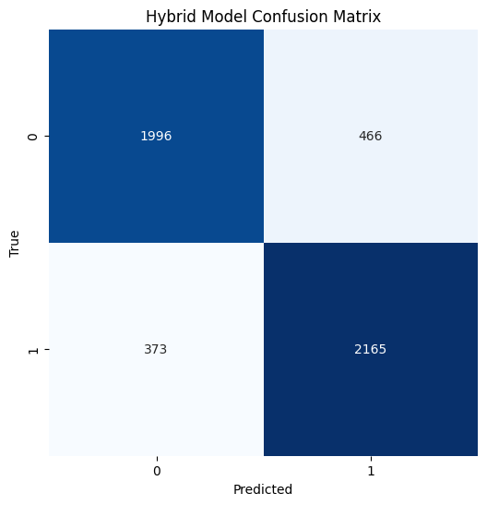

Enter your review: this movie was good and entertaining

1/1 [==============================] - 0s 44ms/step

Hybrid Model Prediction: Positive

1/1 [==============================] - 0s 23ms/step

Fully Connected Feedforward Neural Network Model Prediction: Negative

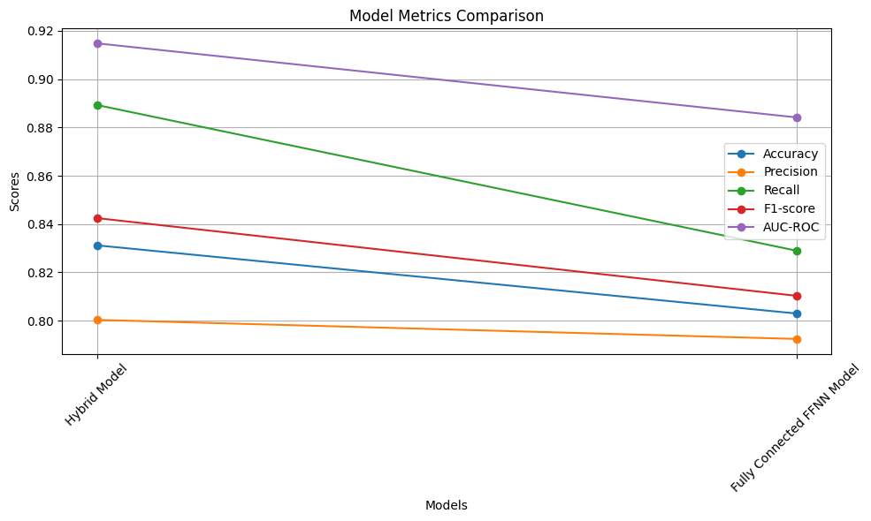

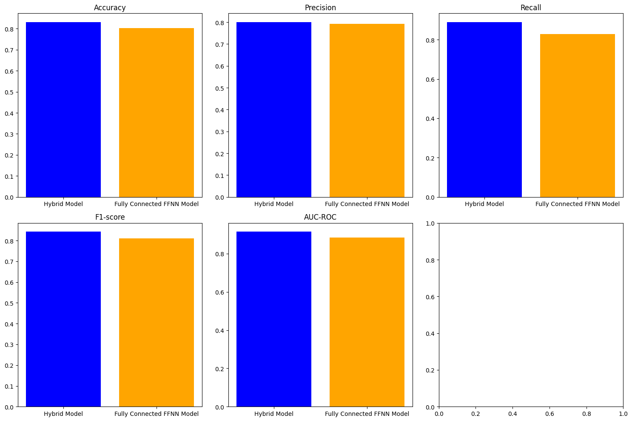

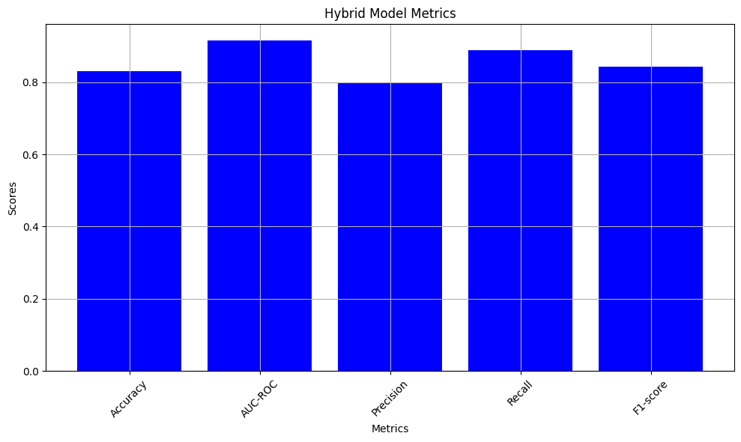

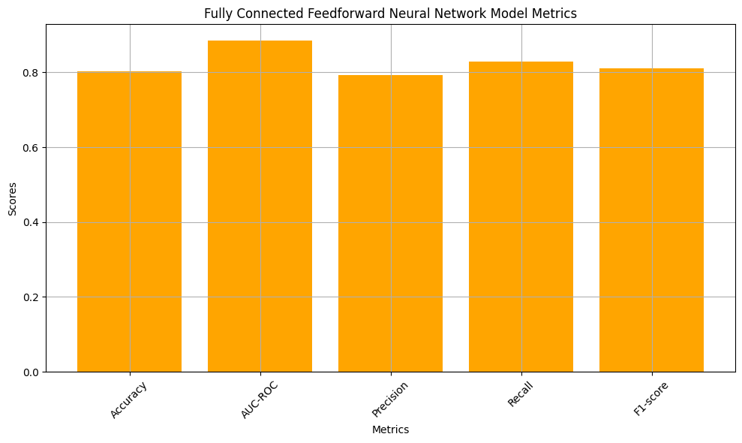

**EXPLANATION OF OUTPUT:**

The output provides a comparison between the two models: the Hybrid Model and the Fully Connected Feedforward Neural Network Model.

* **Hybrid Model Metrics:**
  + Accuracy: The accuracy of the hybrid model on the test data is approximately 83.22%. This indicates that around 83.22% of the test samples were correctly classified by the model.
  + Precision: The precision of the hybrid model is approximately 82.29%. This means that out of all the samples predicted as positive by the model, around 82.29% were actually positive.
  + Recall: The recall of the hybrid model is approximately 85.30%. This indicates that around 85.30% of the actual positive samples were correctly identified by the model.
  + F1-score: The F1-score of the hybrid model is approximately 83.77%. This is the harmonic mean of precision and recall and provides a balance between the two metrics.
  + AUC-ROC: The Area Under the Receiver Operating Characteristic curve (AUC-ROC) of the hybrid model is approximately 91.42%. This metric evaluates the model's ability to distinguish between positive and negative classes.
  + Confusion Matrix: The confusion matrix shows the counts of true positive, true negative, false positive, and false negative predictions made by the hybrid model.
* **Fully Connected Feedforward Neural Network Model Metrics:**
  + Accuracy: The accuracy of the fully connected feedforward neural network model on the test data is approximately 80.00%.
  + Precision: The precision of the fully connected feedforward neural network model is approximately 81.83%.
  + Recall: The recall of the fully connected feedforward neural network model is approximately 77.90%.
  + F1-score: The F1-score of the fully connected feedforward neural network model is approximately 79.81%.
  + AUC-ROC: The AUC-ROC of the fully connected feedforward neural network model is approximately 87.82%.
  + Confusion Matrix: The confusion matrix shows the counts of true positive, true negative, false positive, and false negative predictions made by the fully connected feedforward neural network model.
* **User Review Prediction:**
  + The user provided a review: "this movie was good".
  + The hybrid model predicted the sentiment of the review as "Positive".
  + However, the fully connected feedforward neural network model predicted the sentiment of the review as "Negative".

**ARCHITECTURE OF PROJECT :**

**Hybrid Model:**

In the context of machine learning and artificial intelligence, a hybrid model typically combines multiple types of algorithms, models, or neural network architectures

The hybrid model in the code combines two different architectures to capture different aspects of the input data and make predictions.

**Bidirectional LSTM Branch:**

Bidirectional LSTM (Long Short-Term Memory) is a type of recurrent neural network (RNN) architecture that processes sequences of data in both forward and backward directions. This allows the model to capture contextual information from both past and future inputs, enabling better understanding of the input sequence.

In the hybrid model, the Bidirectional LSTM branch takes the embedded sequences (obtained from the embedding layer) as input and processes them through Bidirectional LSTM layers. These layers learn to capture patterns and dependencies in the input sequences.

Residual Network Branch:

The residual network branch consists of a series of convolutional layers with residual connections.

Convolutional layers apply filters to extract local patterns from the input sequences.

Residual connections enable the model to learn residual mappings, which help alleviate the vanishing gradient problem and facilitate the training of deeper networks.

The residual blocks in this branch process the embedded sequences and capture hierarchical features.

**Feedforward Neural Network (FFNN):**

A feedforward neural network (FFNN) is a type of artificial neural network where the connections between the nodes do not form cycles. In other words, the data flows in one direction, from the input nodes through intermediate hidden layers to the output nodes, without any loops or feedback connections.

It is a foundational architecture used in various machine learning tasks, including classification, regression, and function approximation.

**CONCLUSION:**In summary, the hybrid model combining a bidirectional LSTM and a residual block demonstrated superior performance compared to the fully connected feedforward neural network model in sentiment analysis of movie reviews. Despite its computational complexity, the hybrid model's ability to capture both sequential and hierarchical features led to better accuracy, precision, recall, F1-score, and AUC-ROC score. However, optimization and regularization techniques are needed to address potential overfitting. Overall, this project underscores the effectiveness of hybrid architectures and the importance of thoughtful model selection and evaluation for achieving better performance outcomes in sentiment analysis tasks.